Part 2:

What am I analyzing for this part? I will be analyzing the windows log that have anonymously recorded.

The information I can for this data set is:

the format is DST
Each line contains:
type : “A” the attribute id number of the area of the website for example “A,1228”
The title of the virtualRoot for example “how to update mozilla firefox ”
the stream which tells the relative url for example “http://help.microsoft.com/mozilla”
Vote lines for example “C,"10164",10164
V,1123,1”
Where 'C' stand in this as a case line,
10164' is the case ID number of a user,
'V' marks the vote lines for this case,
'1123', 1009', 1052' are the attributes ID's

The following information is know about the number of records:
Number of Instances:
Training: 32711
Testing: 5000
Attributes: 294
each instance is an anonymous, randomly selected user.

What type of data is there?

A,1038,1,"SiteBuilder Network Membership","/sbnmember"

A = Char
1038 = integer
“title...” = String
“Relative url” = String

There are is only a type record and id of the website that is usefull the tiltle can change overtime thus not handing and not unique the same thing counts for the url.

We can create with the type of record and the id a count thus we can use that to graph the most visited page.

The format of the dataset is in DST

We can not directly import the data into R we need to change the data to csv so that is is easier to handle in R or Python.

I have created a csv and have used head:

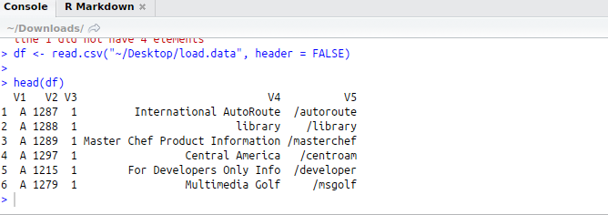
used summary to get a sumarry of the data frame:

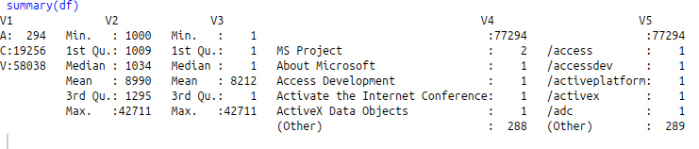
i used str to display the information about the data frame the numbers:

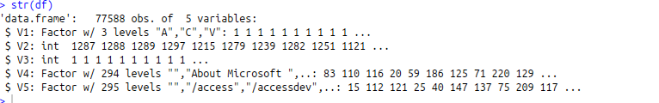

I have table with the type:
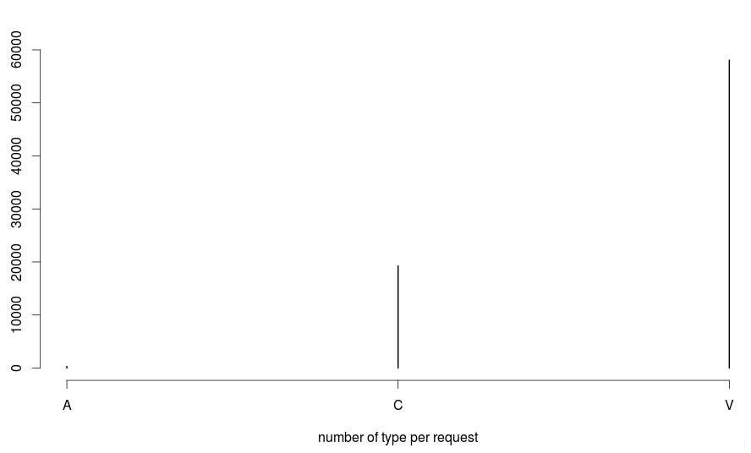
The id thas been mostly request are:

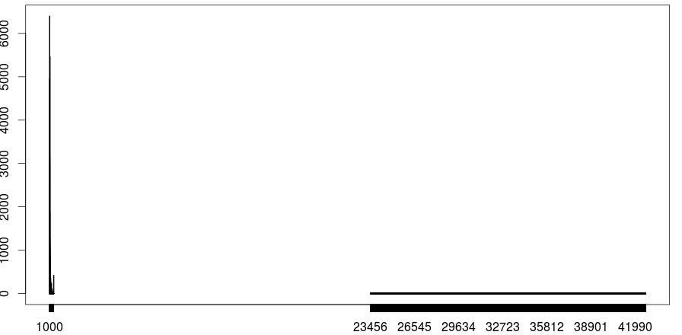
23456 , 26545, 29634, 32723, 35182 38901, 41990 and the post is 1000

